**PRIVATE HOSTEL ASSISTANT**

**A REPORT on project baSED LEARNING**

**(semester -II)**

*Submitted by*

**NAME OF THE CANDIDATE(S)**

|  |  |  |
| --- | --- | --- |
| **Sr.No.** | **Name** | **Roll no.** |
| 1) | Vedant Aher | 10858 |
| 2) | Shrikant Kshirsagar | 10859 |
| 3) | Samir Thokal | 10869 |
| 4) | Bhairu Gavhane | 10872 |

**FIRST YEAR ENGINEERING**



# Society for Computer Technology and Research’s

# PUNE INSTITUTE OF COMPUTER TECHNOLOGY

# DHANKAWADI, PUNE – 43

**A.Y. 2021-22**

# CERTIFICATE

# This is to certify that the report entitled

## Private Hostel Assistant

|  |  |  |
| --- | --- | --- |
| **Name** | **Submitted by**  **Roll No** | **Signature** |
| Vedant Aher | 10858 |  |
| Shrikant Kshirsagar | 10859 |  |
| Samir Thokal | 10869 |  |
| Bhairu Gavhane | 10872 |  |
|  |  |  |

# Is a bonafide work carried out by them under the supervision of Mr. E. M. Reddy and it is approved for the partial fulfilment of the requirement of Project-Based Learning for FE for the award of the Degree of Bachelor of Engineering.

## Mr. E. M. Reddy

PBL Lab Teacher

Place: Pune Date:

**Abstract**

This project is useful to all the students who comes from outside Pune or who lives far away from PICT College. As PICT hostels having limited capacity of students will have to find private hostel for their accommodation to facilities them we have developed a website, that can helps students have to find the private hostels, so we tried to develop a website that can help the students to get all the information of private hostels near PICT College.

This website will provide all information as per the requirement of students and their parents. It is very easy to get you all the information in one click only. We have taken many reviews from the students who lived and have experience of living in private hostels. We provided details of almost all hostels near PICT College.

**ACKNOWLEDGEMENT**

We express our sincere gratitude to **Dr. P.T. Kulkarni** (**DIRECTOR-PUNE INSTITUTE OF COMPUTER TECHNOLOGY**), **Dr. R. Shreemathy** (**PRINCIPAL-PUNE INSTITUTEOF COMPUTER TECHNOLOGY), Prof. E. M. Reddy (H.O.D.-FIRST YEAR ENGINEERING)** for encouraging us to take part in Project Based Learning (PBL) under the guidance of **Prof. E. M. Reddy** acknowledge with thanks the kind of patronage, loving inspiration, and timely guidance which we have received from all the teachers and professors that made this project possible and helped us at the 11thhour. We express deep and sincere gratitude to **Prof. E. M. Reddy** whose guidance, encouragement, suggestions, and very constructive corrections have contributed immensely to the evolution of the ideas involved in the project. We also express immense respect and gratitude to **Prof. Bhavana Vyas** madam who provided us with the necessary material for the project. We would also like to express our heartfelt thanks to our friends and families who helped us in this project and supported us in our times of need by providing valuable information.

**Index**

|  |  |  |
| --- | --- | --- |
| Chapter no | Title | Page no |
|  | Abstract | 3 |
|  | Acknowledgement | 4 |
| 1) | Introduction   1. Introduction to project 2. Objectives | 6 |
| 2) | Literature survey   1. Origin of concept 2. Existing system | 8 |
| 3) | System environment   1. Hardware configuration 2. Software Configuration |  |
| 5) | System Design | 9 |
| 6) | Important Codes | 10 |
| 7) | References |  |

**Chapter 1**

**INTRODUCTION**

**1.1** **Introduction to Project**

As PICT hostel having limited capacity of seats, students will have to find private hostel for their accommodation. Finding a private hostel near PICT College is a difficult task. It involves too much time. Even if they get it by any ways, sometimes it may not suitable for student as their expectations about facilities and price. So we decided to work on a website related to private hostels near PICT College. We have got 20 private hostels near PICT College, which consist of 15 boy’s hostel and 5 girl’s hostel. In this website we provided a sufficient data of respective private hostel as follow:-

* Name
* Contact
* Fees
* Address
* AC rooms
* Available for Boys or Girls
* Hot Water
* Occupancy Option- Twin Sharing, Single room bed, triple Sharing
* Single Bed per Head
* Private Cupboard
* Wi-fi
* CCTV Surveillance
* Purified drinking water(RO)
* Cleaning of rooms
* Gate opening/closing Time

**Why we choose this project?**

When we were admitted to the college, we had a hard time for finding private hostels or PG’s outside the campus. We wasted a lot of time for finding private hostels.

This is a major problem that new students face when they enter in college. They waste lot of time and money for finding the accommodation. We thought that, it’s a time to find easy solution on this problem.

**Objectives:-**

1. Helping the students to compare and find the hostels for free.

2. No middleman will be involved. So students will be saving the brokerage.

3. Students just need an Internet connection for finding and comparing among hostels.

4. Time, money and energy is saved while searching and visiting all hostels.

5. Students will be able to compare and select the hostel on basis of pricing and facility among a large number of hostels available on the website.

6. Our team will try to locate all the hostels nearby PICT by visiting them and gathering the info physically instead of using any form.

7. Hostel owners will be able to reach out to a large group of consumers simply by listing their hostel on a website. This will also save their efforts of finding customers which they do by distributing their visiting cards.

**Chapter 2**

**LITERATURE SURVEY**

* 1. **Origin of Concept:**

# As the number of colleges were increasing day by day the demands for private hostels and PG’s started increasing as per needs of students and the brokers or middlemen started taking advantage of unawareness of students and parents regarding the quality and services. Then some of the hostel companies arrived and tried to privatize this domain.

# As we searched for our hostels and rooms, we faced issues regarding brokerage and lost of time and energy at the same time. That has given us

* 1. **Existing System:**

|  |  |  |  |  |
| --- | --- | --- | --- | --- |
| Title | Author | Year | Aim/Objective | Gaps/Problems |
| Hostel Finder | Karan Patel | June | Goal of the | Maintenance |
| Web |  | 2020 | system is to | of web |
| Application[4] |  |  | increase | application is |
|  |  |  | quality of | not up-to-date. |
|  |  |  | education |  |
|  |  |  | system, it |  |
|  |  |  | allows student |  |
|  |  |  | to find hostels |  |
|  |  |  | on basis of |  |
|  |  |  | their location |  |
|  |  |  | and area. |  |
|  |  |  | Hostel owners |  |
|  |  |  | gets to |  |
|  |  |  | showcase their |  |
|  |  |  | facilities and |  |
|  |  |  | services or |  |
|  |  |  | types of rooms |  |
|  |  |  | available at |  |
|  |  |  | their place. |  |
| Hostel | Mohammed | 2009 | A software | It is working |
| Management | Shahir |  | developed for | only for |
| System[1] |  |  | managing | allocating the |
|  |  |  | various | rooms and not |
|  |  |  | activities in | for dining |
|  |  |  | the hostel, | options and |
|  |  |  | allocating | also not in |
|  |  |  | rooms. | vicinity of |
|  |  |  |  | PICT. |

**Chapter 3**

**SYSTEM ENVIRONMENT**

**3.1 Hardware Configuration:**

1) Intel processor i3 6006U

2) 4 GB Ram

3)256 GB SSD

4)1024*768 Resolution color Display

**3.2 Software Configuration:**

1. OS: Windows 10
2. Browser : Google Chrome
3. XAMPP(cross-platform, Apache, MySQL, PHP and Perl)
4. HTML: HTML is used to create and save web document. E.g. Notepad/Notepad++
5. CSS : (Cascading Style Sheets) Create attractive Layout

**Chapter 4**

**SYSTEM DESIGN**

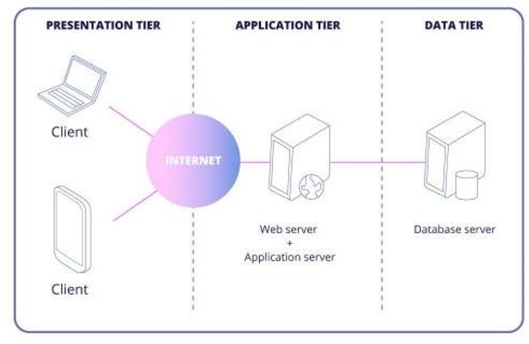

**Fig 4.1**

**UML DIAGRAM:**

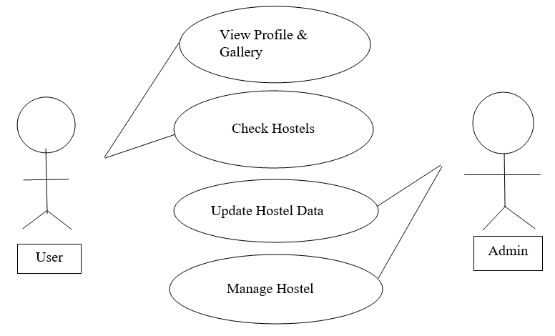

**Fig 4.2**

**5.1 Process Design:-**

Process design plays an important role in project development. In order to understand the working procedure, process design is necessary. Data Flow Diagram and System Flow chart are the tools used for process design.

System Flow Chart is a graphical representation of the system showing the overall flow of control in processing at the job level; specifies what activities must be done to convert from a physical to logical model.

Data Flow Diagram is the logical representation of the data flow of the project. The DFD is drawn using various symbols. It has a source and a destination. The process is represented using circles and source and destination are represented using squares. The data flow is represented using arrows. One reader can easily get the idea about the project through Data Flow Diagram.

**SYMBOLS USED IN DATA FLOW DIAGRAM:-**

|  |  |  |
| --- | --- | --- |
| 1) |  | Source rectangle, which defines start or destination |
| 2) |  | Arrow Represent data flow |
| 3) |  | Rhombus shows Conditions for loops |
| 4) |  | Represent Status of Processing |

**Fig 5.3**

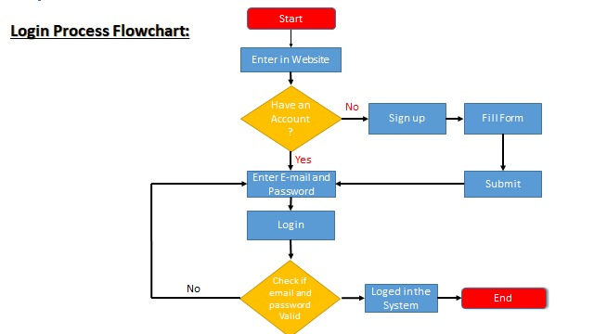

**Fig 4.3**

**Student account creation:-**

|  |  |  |
| --- | --- | --- |
| Field Name | Data type | Description |
| Student Name | Varchar | Name of the student |
| Email-ID | Varchar | Email of the student |
| User Name | Varchar | Username of the student |
| Password | Varchar/ Integer | Password to use |

**Fig 4.4**

**Chapter 5**

**Important codes**

Here are some important codes we used in website development

1. **Login and registration system:**
2. <?php
3. /*include connection file */
4. include "connection.php";
5. // require_once('connection.php')
6. //define variables and initialize with empty values
7. $l_username = $l_password = "";
8. $l_username_errr = $l_password_err = "";
9. //processing from data when form is submitted for login
10. if($_SERVER["REQUEST_METHOD"] == "POST" && isset($_REQUEST["l_submit"])){
11. // check if username is empty
12. if(empty(trim($_REQUEST["l_username"]))){
13. $l_username_err = "please enter username.";
14. }else{
15. $l_username= trim($_REQUEST["l_username"]);
16. }
17. // check is password is empty
18. if(empty(trim($_REQUEST['l_password']))){
19. $l_password_err = "please enter your password";
20. }else{
21. $l_password = trim($_REQUEST['l_password']);
22. }
23. // validate all credentials
24. if(empty($l_username_err) && empty($l_password_err)){
25. // preapre a select statement
26. $sql = "SELECT id, username, password FROM users WHERE username = ?";
27. if($stmt = mysqli_prepare($con, $sql)){
28. // Bind variables to the prepared statement as parameters
29. mysqli_stmt_bind_param( $stmt, "s", $param_l_username);
30. // set variables
31. $param_l_username = $l_username;
32. // attempt to execute the preapred sttatement
33. if(mysqli_stmt_execute($stmt)){
34. // store result
35. mysqli_stmt_store_result($stmt);
36. // check if username exist, if yes then verify the passowrd
37. if(mysqli_stmt_num_rows($stmt) == 1){
38. // Bind result variables
39. mysqli_stmt_bind_result($stmt, $id, $l_useraname, $hashed_password);
40. if(mysqli_stmt_fetch($stmt)){
41. if(password_verify($l_password, $hashed_password)){
42. // password is correct so start new session
43. session_start();
44. // store data in session variables
45. $_SESSION['loggedin'] ==true;
46. $_SESSION['id'] = $id;
47. $_SESSION['l_username'] = $l_username;
48. // REDIRECTING TO USER WECOME PAGE
49. // header('C:\Users\Lenovo\Desktop\HOME\Hostel\privatehostel.website2.me:index.html');
50. // <html><a href = "C:\Users\Lenovo\Desktop\HOME\Hostel\privatehostel.website2.me:index.html">click here </a></html>
51. // echo 'login successful!';
52. header("Location:fol1\index.html");
53. }else{
54. // password is not valid
55. $return_err = "INvalid username or password";
56. }
57. }
58. }else{
59. // USERNAME doesnt exist
60. $return_err = "Invalid Username or Password";
61. }
62. }else{
63. $return_err = "something went wrong please try again later";
64. }
65. // close statement
66. mysqli_stmt_close($stmt);
67. }
68. }
69. // close connection
70. mysqli_close($con);
71. }
72. //---------------------------------------------------------------//
73. $return_err= "";
74. $return= "";
75. $r_username = "";
76. $r_password = "";

2) Style sheet for Login registration page

* {

    margin: 0;

    padding: 0;

    box-sizing: border-box;

}

body {

    font-family: sans-serif;

    font-size: 14px;

    display: flex;

    place-content: center;

    align-items: center;

    flex-wrap: nowrap;

    height: 100vh;

    background: #f9f0ff;

}

.wrapper {

    width: 992px;

    margin: auto;

    overflow: hidden;

    height: 525px;

    display: flex;

    border-radius: 6px;

}

.part1 {

    height: 100%;

    width: 50%;

    background-color: #fff;

    background-image: url(vector1.jpg);

    background-size: cover;

    display: flex;

    align-items: flex-end;

}

.register_title, .login_title {

    margin: 60px;

    color: #fff;

}

.register_title {

    display: none;

}

.part2 {

    height: 100%;

    width: 50%;

    background: #fff;

    padding: 60px;

    -webkit-transition: all 0.3s;

    transition: all 0.3s;

}

.register_wrap {

    display: none;

}

.register_title2,.login_title2 {

    color: #f9300f;

    font-size: 22px;

    margin-bottom: 55px;

    font-weight: bold;

    text-transform: uppercase;

}

.input_content {

    display: grid;

    margin-bottom: 45px;

}

.input_content input {

    padding: 11px;

    border: 1px solid #bbb6b6;

border-radius: 4px;

color: #666;

}

.input_content input[type=submit]{

    background: #9300ff;

    color: #fff;

}

.input_content label {

    font-size: 16px;

    color: #666;

    margin-bottom: 8px;

}

.desc {

    color: #938f8f;

    text-align: center;

}

.desc a {

    font-weight: bold;

}

a {

    color: #9300ff;

    text-decoration: none;

}

 .register_wrap .register_title2, .register_wrap .input_content {

    margin-bottom: 32px  ;

 }

 .desc.result {

    margin-top: 4px;

    margin-bottom: 16px;

    font-size: 12px;

 }

 .desc.result .success {

    color: #2dd733;

 }

 .desc.result .error {

    color: #ff0000;

 }

.mb-0 {

    margin-bottom: 0 !important;

}

1. Connection File:

Which is used to connect the database with the code…

<?php

1. /* database credentials, assuming you
2. are running MySQL server with default setting (user 'root' with no password)*/
3. define('DB_SERVER', 'localhost');
4. define('DB_USERNAME', 'root');
5. define('DB_PASSWORD', '');
6. define('DB_NAME', 'l_hostel');
7. $con = mysqli_connect(DB_SERVER, DB_USERNAME, DB_PASSWORD, DB_NAME);
8. //check connection
9. if($con === false){
10. die("ERROR: could not connect" .mysqli_connect_error());
11. }
12. ?>

3.) Explore tab code…

<!DOCTYPE html>

<html>

<head>

    <title></title>

    <link rel="stylesheet" type="text/css" href="style.css">

         <link href='http://fonts.googleapis.com/css?family=Montserrat:400,700%7CPT+Serif:400,700,400italic' rel='stylesheet'>

          <link href="https://fonts.googleapis.com/css?family=Montserrat|Open+Sans" rel="stylesheet">

</head>

<body>

    <!-- <div class="bgimage"> -->

        <div class="menu">

            <div class="leftmenu">

                <h4> Hostel Assistant </h4>

            </div>

            <div class="rightmenu">

                <ul>

                    <li id="fisrtlist"><a href="index1.html" >HOME</a></li>

                    <!-- <li><a href ="index2.html">Services</a></li> -->

                    <li><a href ="index3.html">Explore</a></li>

                    <li><a href = "index4.html">Aboust us</a></li>

                    <!-- <li>  Blogs </li>

                    <li>contact</li> -->

                </ul>

            </div>

        </div>

        <!-- ======================================== -->

        <p><strong>Filter Hostels by A/C availability:</strong></p>

        <form>

          <label><input type="checkbox" name="flower" value="avail" id="avail" /> Available</label><br>

          <label><input type="checkbox" name="flower" value="unavail" id="unavail" /> Unavailable</label><br>

          </form>

        <!-- <div class="text">

            <h4> DESIGN • DEVELOPMENT • BRANDING </h4>

            <h1> CREATIVE & EXPERIENCED </h1>

            <h3> WE ARE THE ONE OF THE WORLD’S TOP CREATIVE DESIGN AGENCIES </h3>

            <button id="buttonone"> like share </button>

            <button id="buttontwo"> Subscribe </button>

        </div> -->

    <!-- </div> -->

    <!-- ==============DIVSION BLOCK STARTS=============== -->

    <div class="flower" data-id="gurukul" data-category="avail">

    <div class="container">

        <div class="colum">

          <div Class= "h_title">

            Gurukul Boys Hostel

          </div>

          <div>

            Contact- 7798725326, 8624024830<br>

            Fees- Rs.5000 per month<br>

            Address- Sr No.33, Chowk, Near Trimurti, behind Bharathi Vidyapeeth, Katraj, Pune, Maharashtra 411046<br>

            Ac rooms- Not available<br>

            Available for Boys<br>

            24/7 Hot water<br>

            Occupancy Options- Twin sharing, Single room bed<br>

            Single Bed per Head<br>

            Private Cupboard Available<br>

            Wifi Available<br>

            CCTV Surveillance<br>

            Purified drinking water(RO)<br>

            Rooms are cleaned daily<br>

            Gate opening Time- 6 am<br>

            Gate closing time- 11 pm<br>

          </div>

          <div>

          <button class="btn1"><a href="https://wa.me/+917798725326">

            <img src="C:\xampp\htdocs\login\fol1\wp.ico" style="width: 65px;height: 65px;"></a>

          </button>

          <button class="btn2" style="margin-left: 100px;"><a href="https://wa.me/+918624024830">

            <img src="C:\xampp\htdocs\login\fol1\wp.ico" style="width: 65px;height: 65px;"></a>

          </button>

          </div>

        </div>

      <div class="image">

        <!-- SLIDE SHOW CONTAINER STARTS HERE -->

        <div id="slideshow1" class="slideshow-container">

            <div class="mySlides fade" style="display: none;">

              <div class="numbertext">1 / 3</div>

              <img src="C:\xampp\htdocs\login\fol1\gurukul1.jpg" style="width:100%">

              <div class="text">Caption Text</div>

            </div>

            <div class="mySlides fade" style="display: none;">

              <div class="numbertext">2 / 3</div>

              <img src="C:\xampp\htdocs\login\fol1\gurukul2.jpg" style="width:100%">

              <div class="text">Caption Two</div>

            </div>

            <div class="mySlides fade" style="display: block;">

              <div class="numbertext">3 / 3</div>

              <img src="C:\xampp\htdocs\login\fol1\gurukul1.jpg" style="width:100%">

              <div class="text">Caption Three</div>

            </div>

            <a class="prev" onclick="plusSlides(-1,slideshow1)">❮</a>

            <a class="next" onclick="plusSlides(1, slideshow1)">❯</a>

            <div style="text-align:center">

              <span class="dot" onclick="currentSlide(1, slideshow1)"></span>

              <span class="dot" onclick="currentSlide(2, slideshow1)"></span>

              <span class="dot active" onclick="currentSlide(3, slideshow1)"></span>

            </div>

            </div>

            <br>

            <!-- =====================SLIDE SHOW CONTAINER EDS HERE===================== -->

      </div>

  </div>

  </div>

**Chapter 6**

**Implemention**

In this chapter we will take a look of actual working of website

1. First page will be login and registration windows like shown in fig below:

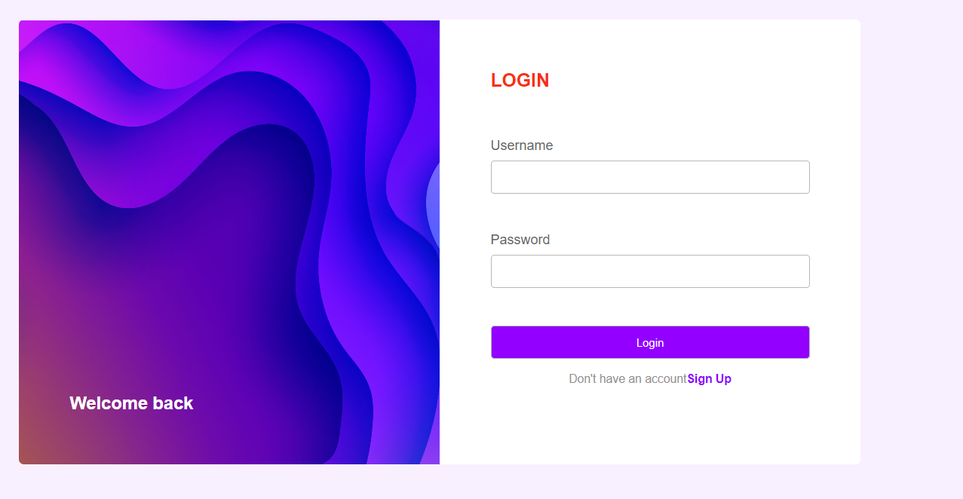

**Fig 6.1**

Here one can login if his account is already been created otherwise he/she will have to create an account to get access to website,

1. To create an account click on Sign up button below login button…

Here entering details along with password in respective fields, one can be able to create an account to access website

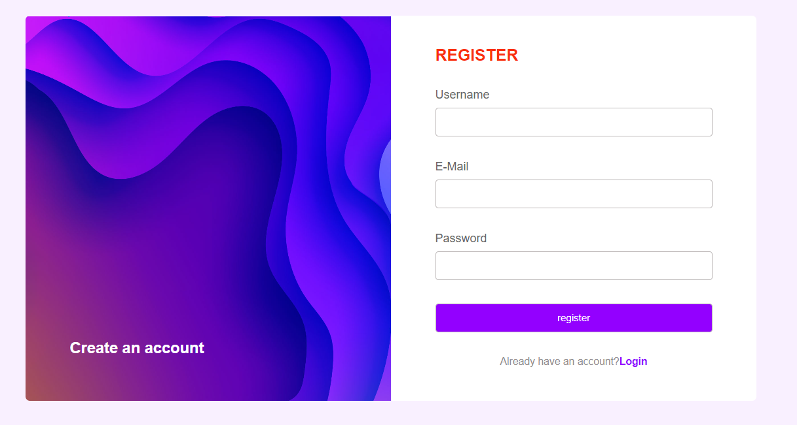

**Fig 6.2**

1. After successful login user will be redirected to the actual website home page

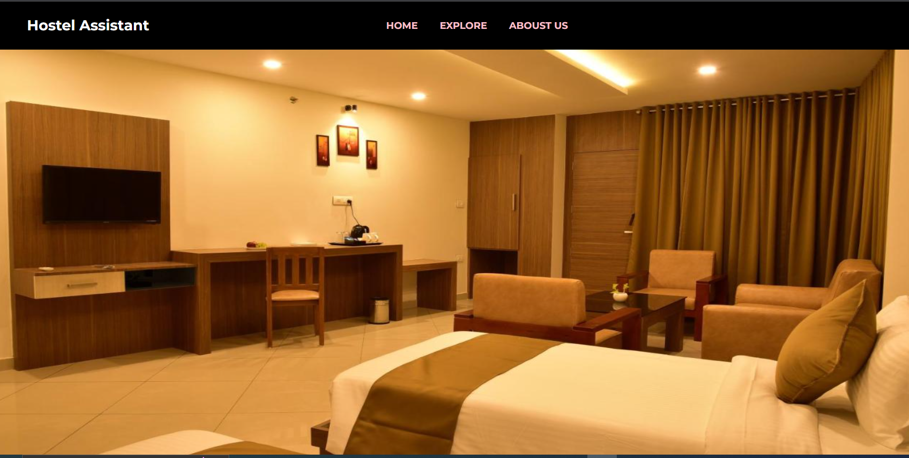

**Fig 6.3**

1. Explore

Click on explore tab to get the detailed information of Hostels

Webpage will looks like fig shown below:

**Fig 6.4**

**Reference:**

1. *https://*[*www.w3schools.com*](http://www.w3schools.com)
2. *https://www.codepen.io*
3. *https://www.mobidev.biz*

**Chapter 7**

**CONCLUSION**

The proposed system will be useful for students in PICT to offer best solution for the private hostel problems outside the campus they are facing in the web development domain.

This system will provide the solution for all the students searching for hostels without any mental harassment and will save their time and energy at the same time.